**Thwandar, The Hunter**

**Story**

Thwandar was once part of bipedal race of hunters that relied on traps for survival. He eventually got immensely proficient with guns during the civil war, becoming a self-preservation expert and trapping master. The cube only aided in this, allowing him reuse destroyed traps and make them new again, while also improving his aim to make him extremely deadly.

**Health:** 10000

**Phase switch:** 50% health left.

**Damage:** See “Attack”

**Aesthetic**:

* Bounty hunter
* Bunch of weapons and adaptable pieces.
* Cyborg esc
* One eye

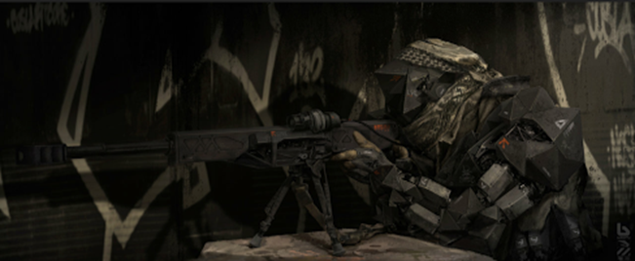

*(Art from Google)*

**Depth Mechanic:**

* The rooms leading up to this boss with have much more traps I.e. there will be rooms specific to this depth

**Music:**

* **Techno**

**Boss Room:**

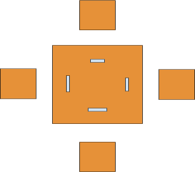

**Phase 1**

**Movement:**

* Walks at a quick speed

**Mechanic:**

* He must reload, but mostly he is like a perfect version of the player and focuses on trapping the player.

**Attacks:**

* **Attack 1**: Basic Attack
  + **Range:** Moderate
  + **Damage:** 10-15%(per hit)
  + **Effect:** Fires his rifle
* **Attack 2**: Drop Mine
  + **Range:** Long/Short
  + **Damage:** 50%(per hit)
  + **Effect:** Shoots a mine that’s triggered by proximity. Can be destroyed by shooting.
* **Attack 3**: Hook
  + **Range:** Moderate
  + **Damage:** 75%(per hit)
  + **Effect:** Spins a hook and casts it towards the player. If it connects, he pulls the character and fires a bullet into the plays head dealing massive damage. Shielding bounces the hook away.
* **Attack 4**: Stasis Mine
  + **Range:** Long/Short
  + **Damage:**0
  + **Effect:** Traps the player for Thwandar to shoot at. Mine can be destroyed.

**Weak Point:**

* Back

**Phase 2**

Yells and gains a new move which he will use at 50%, 30% and 10% health intervals. He Hooks to the floating platforms that are outside the room and lines up 3 sniper shots at the player

* **Attack**: Rapid Shot
  + **Range:** Long
  + **Damage:**50%(Per Shot) 3 shots
  + **Effect:** Fires three fast sniper shots with deadly accuracy at the player.

**Weapon:** The Eye of Thwandar

**Type**: Sniper rifle

**Magazine size:** 3

**Damage:** Very high

**Effect:** Best range, does extremely high damage. Fires three bullets in rapid succession.